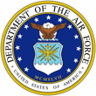 Biography 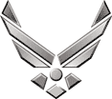

***U N I T E D S T A T E S A I R F O R C E***

**CHIEF MASTER SERGEANT JAMES R. LYDA**

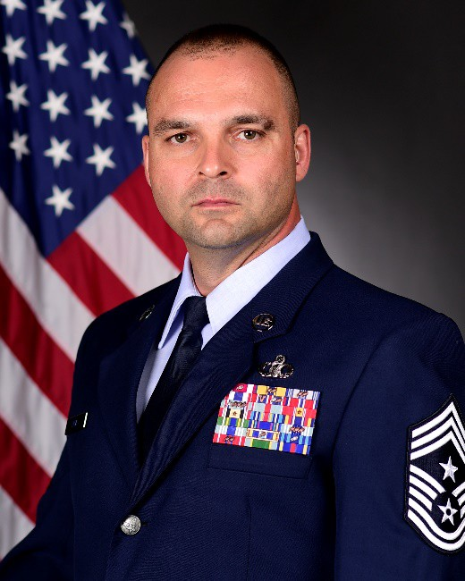Chief Master Sergeant James R. Lyda is the Command Chief Master Sergeant, 355th Wing, Davis-Monthan Air Force Base, Ariz. He is the principle enlisted advisor to the installation commander and staff on mission effectiveness, professional development, military readiness, training, utilization, health, morale, and welfare of the command’s 5,200 Enlisted Airmen. The 355th Wing operates the A-10 Thunderbolt II, HH- 60G, and HC-130J as well as three Guardian Angel squadrons comprising the Rescue and Attack mission. Additionally, Chief Master Sergeant Lyda provides leadership and direction for Total Force support to Active Duty, Guard, Reserve, Customs and Border Patrol agencies encompassing 34 mission partners, 11,000 Airmen, 152 aircraft and $50 billion dollars in assets.

Chief Master Sergeant Lyda entered the Air Force in July 1991. His background includes various leadership positions at the squadron, group, wing and major-command levels. Throughout his career, he has filled a multitude of roles including Wing Command Chief, Superintendent of a Combat Plans Division and the first-ever Superintendent of Air Traffic Control at Spangdahlem AB, Germany. Additionally, Chief Master Sergeant Lyda has deployed in support of Operations IRAQI FREEDOM and ENDURING FREEDOM. Prior to his current assignment, Chief Master Sergeant Lyda served as the Command Chief, 509th Bomb Wing, Whiteman AFB, Mo.

# EDUCATION

1991 Air Traffic Control Technical School, Keesler Air Force Base, Miss.

1997 Airman Leadership School, Minot AFB, N.D.

2005 Non-Commissioned Officer Academy, Maxwell AFB, Ala.

2007 Associate Degree, Airway Science, Community College of the Air Force

2010 Senior Noncommissioned Officer Academy, Maxwell AFB, Ala.

2014 Professional Managers Certification, Community College of the Air Force

# ASSIGNMENTS

1. July 1991 – August 1991, Trainee, Basic Military Training, Lackland Air Force Base, Texas

2. September 1991 – December 1991, Trainee, Air Traffic Control Training School, Keesler AFB, Miss

3. January 1991 – August 1994, Air Traffic Controller, 23d Operations Support Squadron, Pope AFB, N.C.

4. August 1994 – November 1998, Air Traffic Controller, 5th Operations Support Squadron, Minot AFB, N.D.

5. December 1998 – December 1999, Air Traffic Controller, 8th Operations Support Squadron, Kunsan Air Base,

Republic of Korea

6. December 1999 – May 2003, Watch Supervisor, Air Traffic Control, 4th Operations Support Squadron, Seymour Johnson AFB, N.C.

7. December 2003 – June 2004, Terminal Instrument Procedures Specialist, 4th Operations Support Squadron, Seymour Johnson AFB, N.C.

8. June 2004 – August 2007, Command Terminal Instrument Procedures Specialist, Air Combat Command, Langley AFB, Va.

9. September 2007 – September 2008, Superintendent, Combat Plans Division, 607th Air & Space Operations Center, Osan AB, Republic of Korea

10. September 2008 – November 2011, Superintendent Air Traffic Control, Spangdahlem AB, 52d Operations Support Squadron, Spangdahlem AB, Germany

11. December 2011 – October 2014, Chief Controller, Dakota Air Traffic Control Facility & Supt, 28th Operations Support Squadron, Ellsworth AFB, S.D.

12. October 2014 – October 2015, Chief Controller, Radar Approach Control, 51st Operations Support Squadron, Osan AB, Republic of Korea

13. October 2015 – May 2016, Superintendent 509th Operations Support Squadron, Whiteman AFB, Mo.

14. May 2016 – July 2017, Superintendent 509th Operations Group, Whiteman AFB, Mo.

15. October 2017 – May 2019, Command Chief, 509th Bomb Wing, Whiteman AFB, Mo.

16. May 2019 – Present, Command Chief, 355th Wing, Davis-Monthan AFB, Ariz.

# MAJOR AWARDS AND DECORATIONS

Legion of Merit

Meritorious Service Medal with five oak leaf clusters

Air Force Commendation Medal with two oak leaf clusters

Air Force Achievement Medal with two oak leaf clusters

# OTHER ACHIEVEMENTS

1998 Air Traffic Controller of the Year, 5th Bomb Wing, Minot AFB, N.D.

1999 Air Traffic Controller of the Year, 8th Fighter Wing, Kunsan AB, Republic of Korea

2001 Air Traffic Controller of the Year, 4th Fighter Wing, Seymour Johnson AFB, N.C.

2002 Air Traffic Control Training Achievement of the Year, Air Combat Command, Seymour Johnson AFB, N.C.

2002 North Carolina Governors Award for Group Volunteers, Seymour Johnson AFB, N.C.

2003 Terminal Instrument Procedures Specialist of the Year, 4th Fighter Wing, Seymour Johnson AFB, N.C.

2004 Noncommissioned Officer of the Year, Air Combat Command, Langley AFB, Va.

2005 Noncommissioned Officer of the Year, Air Combat Command, Langley AFB, Va.

2005 Distinguished Graduate, Noncommissioned Officer Academy, Maxwell AFB, Ala.

2006 Operations Noncommissioned Officer of the Year, Air Combat Command, Langley AFB, Va.

2007 Senior Noncommissioned of the Year, 607th Korean Air & Space Operations Center, Osan AB, Republic of Korea

2009 Air Traffic Control Enlisted Manager of the Year, 52d Fighter Wing, Spangdahlem AB, Germany

2010 Senior Noncommissioned Officer of the Year, 52d Operations Support Squadron, Spangdahlem AB, Germany

2010 Air Traffic Control Enlisted Manager of the Year, 52d Fighter Wing, Spangdahlem AB, Germany

# EFFECTIVE DATES OF PROMOTION:

Airman Basic July 16, 1991

Airman January 16, 1992

Airman First Class November 16, 1992

Senior Airman July 16, 1994

Staff Sergeant July 1, 1999

Technical Sergeant July 1, 2003

Master Sergeant June 1, 2007

Senior Master Sergeant March 1, 2010

Chief Master Sergeant December 1, 2012

(Current as of July 2020)